**Lab 1: Understanding ORM with a Retail Inventory System**

### ****STEP 1: Understand ORM****

**What is ORM?**

ORM (Object-Relational Mapping) is a technique that connects your application’s object-oriented model (C# classes) with a relational database (like SQL Server).

**How it works in EF Core:**

1. C# **classes** map to **tables**
2. Class **properties** map to **columns**
3. **Relationships** (e.g., navigation properties) map to **foreign keys**
4. EF Core handles CRUD operations under the hood using LINQ

**Benefits of ORM:**

1. No need to write raw SQL for most operations
2. Easier to maintain & read
3. Supports unit testing and code reuse

**Step 2: EF Core vs EF Framework (EF6)**

| **Feature** | **EF Core 8.0** | **EF Framework 6 (EF6)** |
| --- | --- | --- |
| 1. Platform | Cross-platform (.NET) | Windows-only (.NET Framework) |
| 1. Performance | Faster with compiled models | Slower |
| 1. Modern Features | LINQ, async, interceptors | Limited support |
| 1. Flexibility | More lightweight & modular | Monolithic |
| 1. JSON Column Mapping | Supported | Not supported |

**STEP 4: Create the .NET Console App**

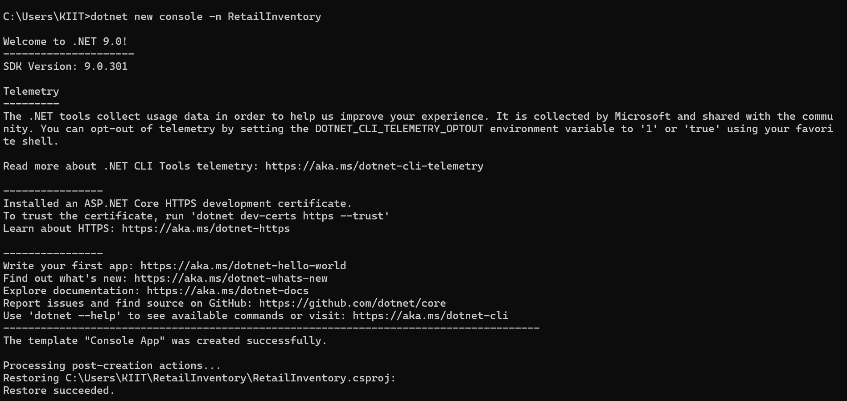

**Screenshot 2025-07-05 185717**

**STEP 5: Install EF Core Packages**

